**MODALS OF OBLIGATION**

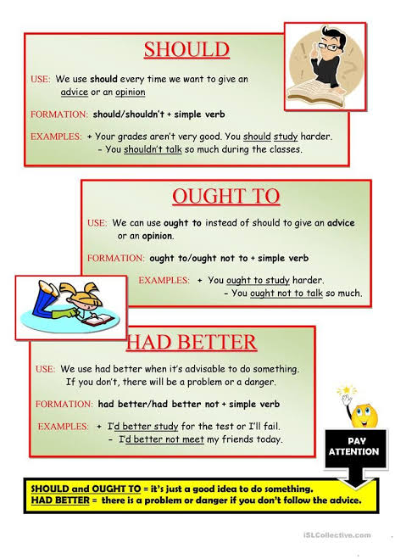

**Usando el cuadro de arriba sobre los modals of obligation contestar la siguiente actividad:**

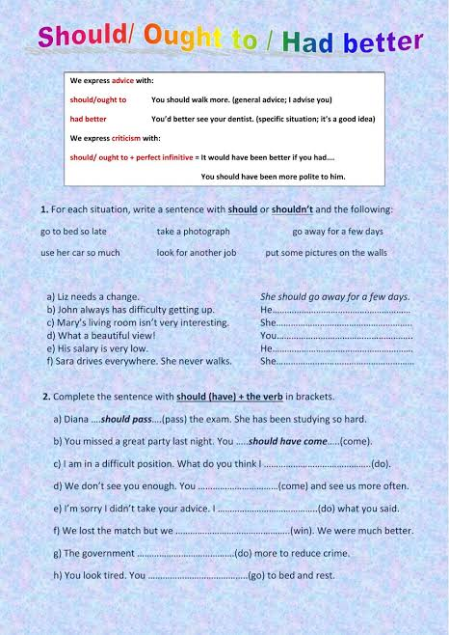

**IT’S + ADJECTIVE + INFINITIVE**

Use **it’s + adjective + infinitive** to give your opinión.

Examples:

* ***It’s important to talk*** *to others when you’re stressed.*
* ***It’s not helpful to think*** *negative thoughts.*

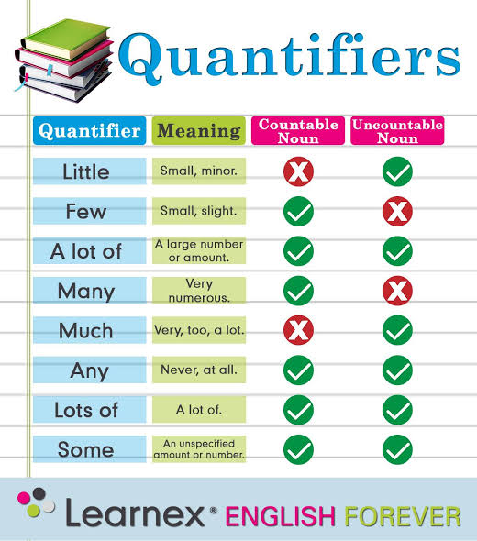

**EMOTIONS**

